**PRE-LAB REPORT**

**Experiment No :** 06

**Name of The Experiment : Experimental study of inverting, non-inverting, summing, differential and unity buffer amplifier.**

1. **Inverting Operational Amplifier:**

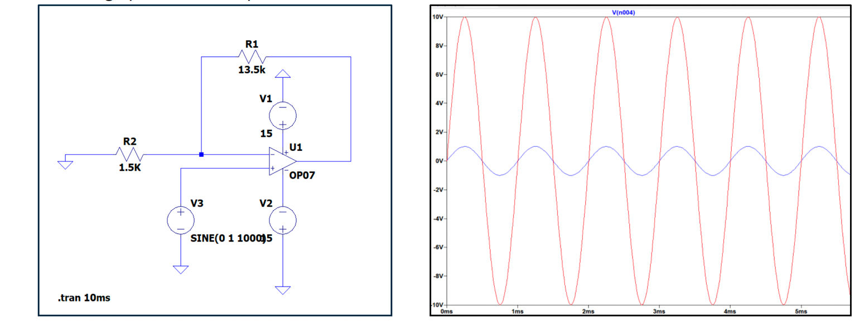

**Fig – 01 : Inverting Operational Amplifier**

1. **Non-inverting operational amplifier :**

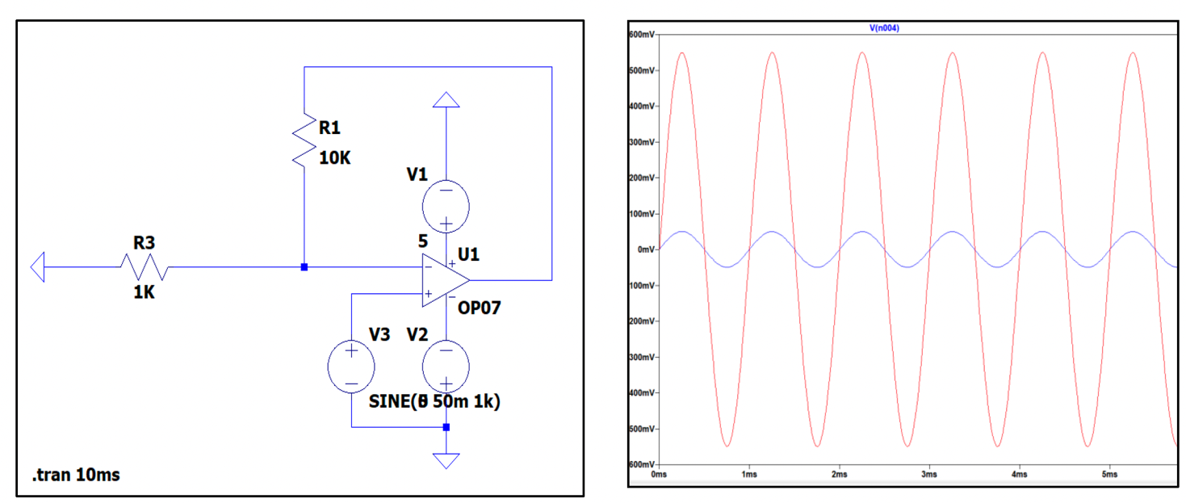

**Fig – 02 : Non-inverting Operational Amplifier**

1. **Summing Amplifier :**

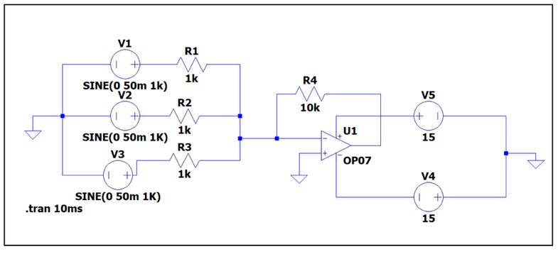 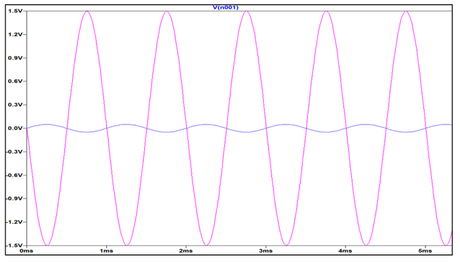

**Fig – 03 : Summing Amplifier**

1. **Differential Amplifier :**

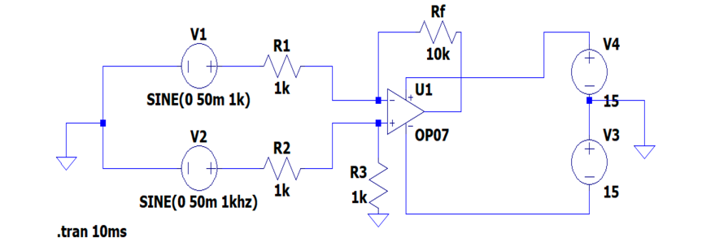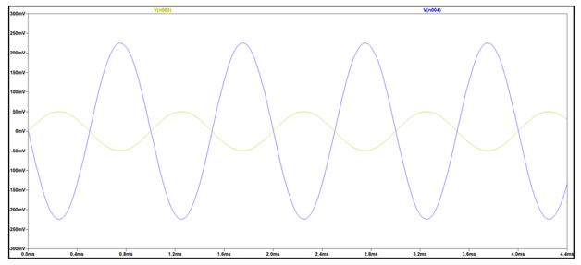

**Fig – 04 : Differential Amplifier**

1. **Summing Amplifier :**

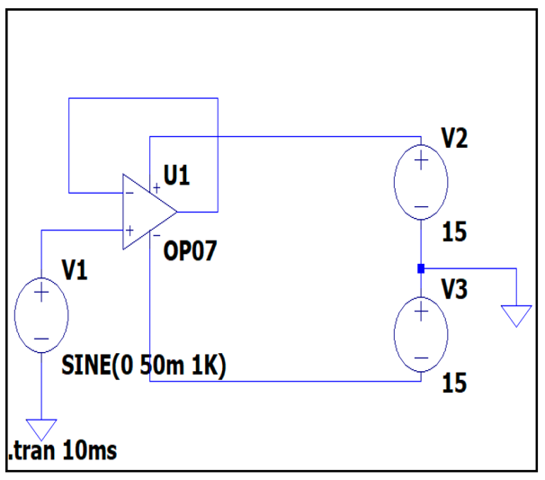 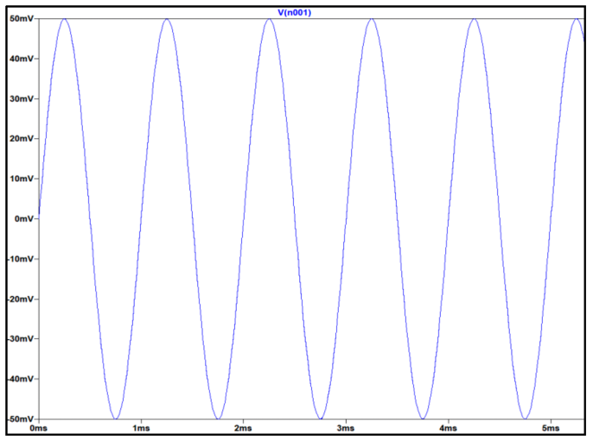

**Fig – 05 : Summing Amplifier**